

Market Conduct Annual Statement
CSV Creator Instruction Guide
2024 Data Year Filings

National Association of Insurance Commissioners
2024

Basic Instructions
The NAIC has created an Excel workbook that will allow you one quick place for the data entry of all your data to create a correctly formatted CSV file to use for uploading your data. This workbook is not required to be used, it is being provided as a convenience feature for your benefit. The following is a broad overview of how to use the files. While each file has different data entry required to submit the data for a particular line of business, they all work the same. We will be using the Homeowner’s file as the example file in this documentation.

The first sheet in the workbook, titled “Instructions – READ FIRST” (in red) includes relevant information to filling out the spreadsheets to create a CSV file for your company. You will need to fill in your NAIC company code on this sheet, which is highlighted in yellow. Once you have entered the NAIC company code, it will link through to other tabs within the Excel workbook.

Data Entry
Next, you will want to fill out the spreadsheets containing the “blanks” for your data. These are found in the tabs with names to match the MCAS User Guide and are colored orange. The first spreadsheet in our example is the HO Interrogatories (HOINT). Here you will see all of the questions listed out across the columns that you can find in the Blanks and MCAS Homeowner’s Data Call and Definitions. The rows are each state. If you only want to fill out data for AZ, CA, and NV, for example, you can filter the column titled “State” to just these states. To filter you will press the little triangle shape in the square next to State. Uncheck states you won’t be filing in. (Or, alternatively, uncheck “Select All” and then recheck only the states that you wish to file in.) Each cell has validations around it that will only allow you to enter data that matches the type of data required in the CSV Upload Guide. For instance, each response in the “Data to report for Dwelling?” column is expected to be either “Y” or “N”. The only values that may be entered in the cells under this question are “Y” or “N”. Any cells that have numeric entry requirements have validations around them that will allow only numeric entries. For questions that say “If yes, explain” the cell width is small. Once you finish entry and press return, it will seem to disappear. You can see what is typed in the formula bar. You may need to adjust the size of the formula bar. See Figure 1. (You may also adjust the width of the column, if you wish.)
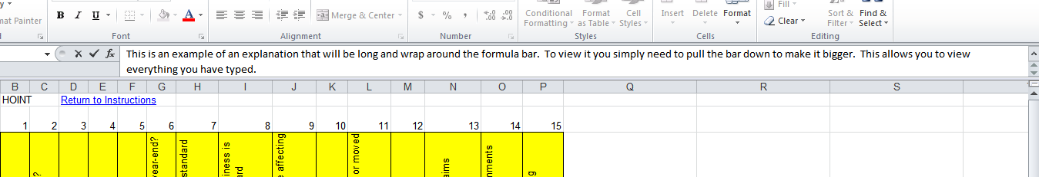
Figure 1. You can hover over this and get a two-ended arrow that will allow you to adjust it to be bigger or smaller. (Click and hold, then drag up and down.)

The HO Claims (HOCLMS) spreadsheet is going to be filled out similarly. You may also wish to filter the states on this spreadsheet. However, in this spreadsheet, each question has 5 different coverage types under it. For instance, cell B5 is the “Number of claims open at the beginning of the period” for the coverage type dwelling in Alaska. Fill out the remainder of this spreadsheet in the same manner. If you are filling out the cells and, after pressing return/enter, you find the cell now displays #### you may adjust the column width. (Place your cursor on the line at the top between the columns after the column you wish to adjust. When it turns to a black vertical line with arrows pointing left and right, you can click and hold on the line. Pull the mouse left or right to adjust the column width.)
The HO UW Activity (HOUNDACT) spreadsheet will be filled out similar to the Interrogatories spreadsheet. You will only have numeric entry here. Fill it out for each state (filtered if you wish) and adjust column widths as needed.
Note about commas:
Please note that if you have data with commas, you will need to enclose all of this data in quotation marks to make the CSV upload work. Here are two examples:
Incorrect Entry: This data has commas, as you can see.
Correct Entry: “This data has commas, as you can see.”
We recommend to limit/remove commas in your data to avoid errors.

CSV Creation
The final two spreadsheets are identical with the exception of how they are sorted. They format the data for upload via CSV. These spreadsheet tabs are colored green. The first green spreadsheet “Final CSV File (sort by record)” sorts by record type. So, all of question one is together for every state, all of question 2 is together for every state, etc. The second green spreadsheet “Final CSV File (sort by state)” groups all of the states together. You will see question 1, 2, 3, etc for Alaska listed first, then Alabama and so forth.
Next, go to the sheet that contains the CSV records in a way in which you would like them sorted. Select the drop down arrow in column B and filter (described earlier) to only states that you are reporting data in.
Finally, to copy your data for submission, from the sheet that contains the CSV records that you filtered:
- Highlight the rows in column A where you have data
- Copy these cells.
- Open Notepad.
- Paste the data into notepad.
- Delete the top row that says "Copy These Cells - Delete this Line in Notepad"
- In notepad, choose File -> Save As…
- Name your file as you choose but end it with ".csv" (without the quotations and remove the ".txt" that notepad automatically adds).

The .csv file you created in Notepad and named with a .csv extension is what you are going to use to upload into the MCAS Data Upload tool. You can find further upload instructions in the CSV Upload Guide.
NOTE: If you have multiple lines of business to upload, you can combine the CSV files created for each line to only have one upload per Company Code

